Multiple-choice section – choose the correct answer

Question 1 [4.1]

The perimeter of the triangle below is:

**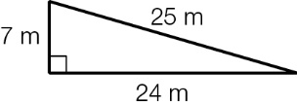**

A 560 cm B 84 m C 56 m D 31 m

Question 2 [4.1]

The arc length of the sector below, correct to 2 decimal places, is:

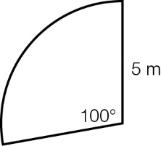

A 8.73 m B 31.42 m C 22.5 cm D 8.72 m

Question 3 [4.1]

The perimeter of the compound shape below is:

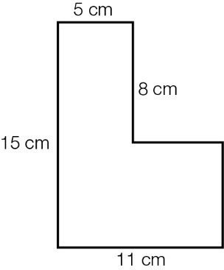

A 39 cm B 52 cm C 47 cm D 55 cm

Question 4 [4.2]

155 cm2 is equivalent to:

A 1.55 m2 B 0.155 m2 C 0.0155 m2 D 0.001 55 m2

Question 5 [4.2]

The area of the parallelogram shown is:

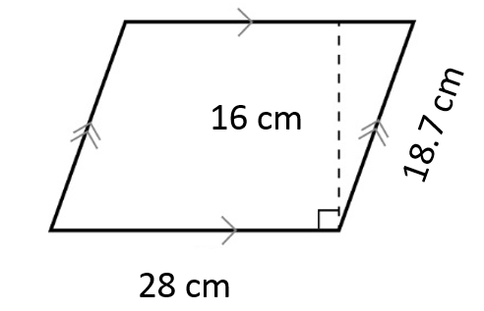

A 62.7 cm2 B 88 cm2 C 448 cm2 D 523.6 cm2

Question 6 [4.2]

The area of this composite shape is:

|  |  |
| --- | --- |
|  | A (12 × 7) + (12 × 8) cm2  B (12 × 15) + (× 12 × 8**)** cm2  C (12 × 17) + (× 12 × 8**)** cm2  D (12 × 7) + (× 12 × 8**)** cm2 |

Question 7 [4.3]

The surface area (SA) of the solid below is:

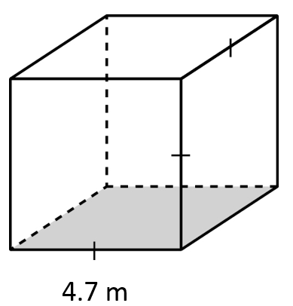

A 4.7 × 4.7 × 4.7 m3 B 6 × 4.7 × 4.7 m3 C 4.7 + 4.7 + 4.7 m3  D 4 × 4.7 × 4.7 m3

Question 8 [4.3]

The total surface area of the following prism is:

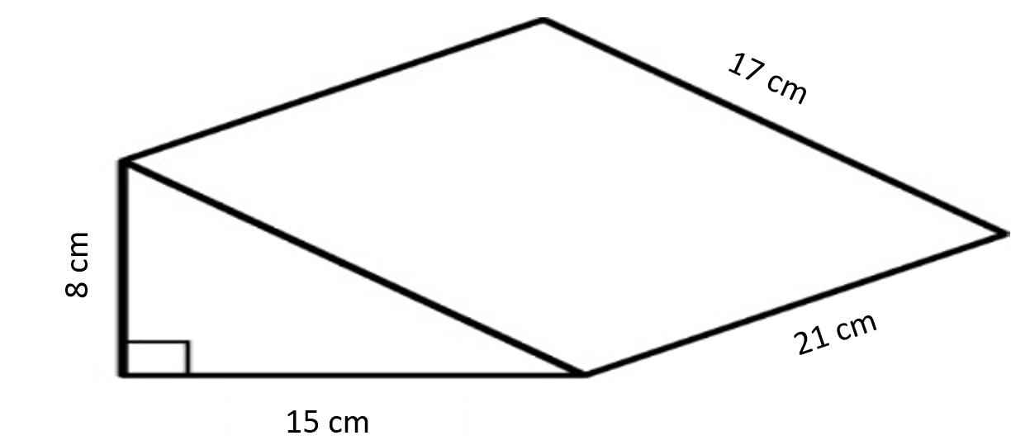

A 645 cm2 B 840 cm2 C 960 cm2 D 1080 cm2

Question 9 [4.4]

2.4 m3 is equivalent to:

A 240 cm3 B 2400 cm3  C 24 000 cm3 D 2 400 000 cm3

Question 10 [4.4]

The volume of this prism is:

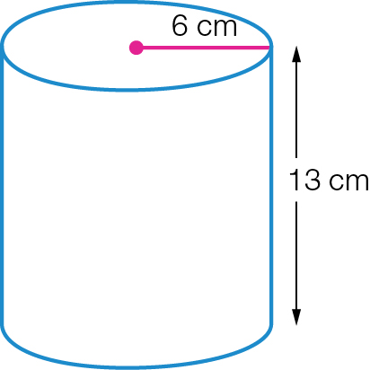

A π × 62 × 13 cm3 B π × 132 × 6cm3 C 13 × 12cm3 D 2 × π × 6 × 13cm3

Multiple-choice results: \_\_\_ / 10

Short answer section

Question 11 6 marks [4.1]

Calculate the perimeter of the following shapes (to 2 decimal places where necessary).

|  |  |  |
| --- | --- | --- |
| (a) | (b) | (c) |

Question 12 4 marks [4.1, 4.2]

Calculate the perimeter and the area of the following sector, correct to 2 decimal places.

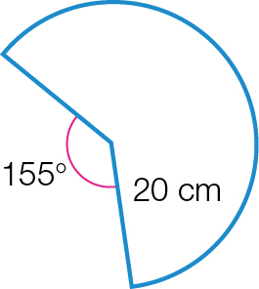

Question 13 2 marks [4.1]

Before school, Jodie jogs around a rectangular area with dimensions 82 m by 25 m. If she jogs around this block 10 times, how far has she jogged? Give your answer in kilometres.

Question 14 4 marks [4.2]

Complete the following area conversions.

(a) 8.1 cm2 = \_\_\_\_\_\_\_\_\_\_\_\_\_\_\_ mm2

(b) 32.8 m2 = \_\_\_\_\_\_\_\_\_\_\_\_\_\_\_\_\_\_\_\_ cm2

(c) 654 000 cm2 = \_\_\_\_\_\_\_\_\_\_\_\_\_\_\_ m2

(d) 0.43 ha = \_\_\_\_\_\_\_\_\_\_\_\_\_\_\_ cm2

Question 15 6 marks [4.2]

Find the shaded areas of the following composite shapes (to 2 decimal places where necessary).

(a)

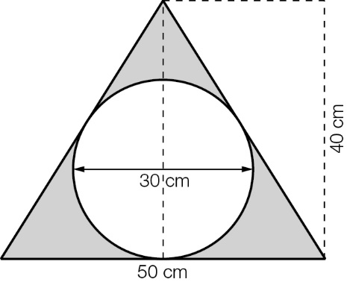

(b)

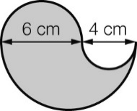

Question 16 8 marks [4.3, 4.4]

For the following solids, find, correct to 2 decimal places:

(a) the surface area

(b) the capacity in litres

|  |  |
| --- | --- |
| (i)  C:\Users\Maja\Desktop\Pixel & Ink\Clients\Pearson\Pearson Maths 9 2ed\8 eBook\Batch 1\_SUPPLIED_V1_CORREX_080916\_SUPPLIED_V1_CORREX_080916\PM2e_09_EB_04_SBT_04.jpg | (ii)  ACPM9_PR_4_20tsa |

Short answer results: \_\_\_ / 30

Extended answer section

Question 17 7 marks [4.1, 4.2, 4.4]

A roof of a shed made up of a rectangle with a triangle at one end is shown below.

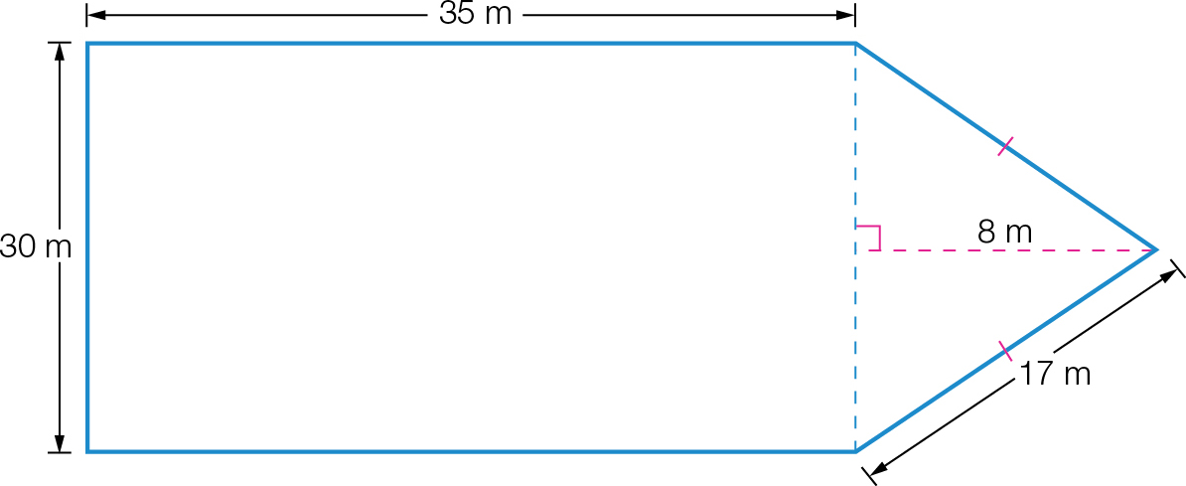

(a) Find the perimeter of the roof.

Gutters are to be installed around the edges of the roof at a cost of $3.50 per metre.

(b) Find the total cost of the gutters.

(c) Find the area of the roof.

(d) The shed also has a water tank with a capacity of 21.5 kL. How many cubic metres is the tank?

(e) It rained heavily and the water went straight into the tank. Given the area of the roof, at what depth would the rainwater need to be collected from the roof to completely fill the tank? Give your answer in centimetres, correct to 2 decimal places.

Question 18 8 marks [4.2, 4.3, 4.4]

Peter is landscaping his backyard. The diagram below shows that he will have a semicircular pond at the top end, along with two triangular garden beds on the sides of his trapezium yard. Apart from the pond and the garden beds, the rest of the backyard will be covered with buffalo grass.

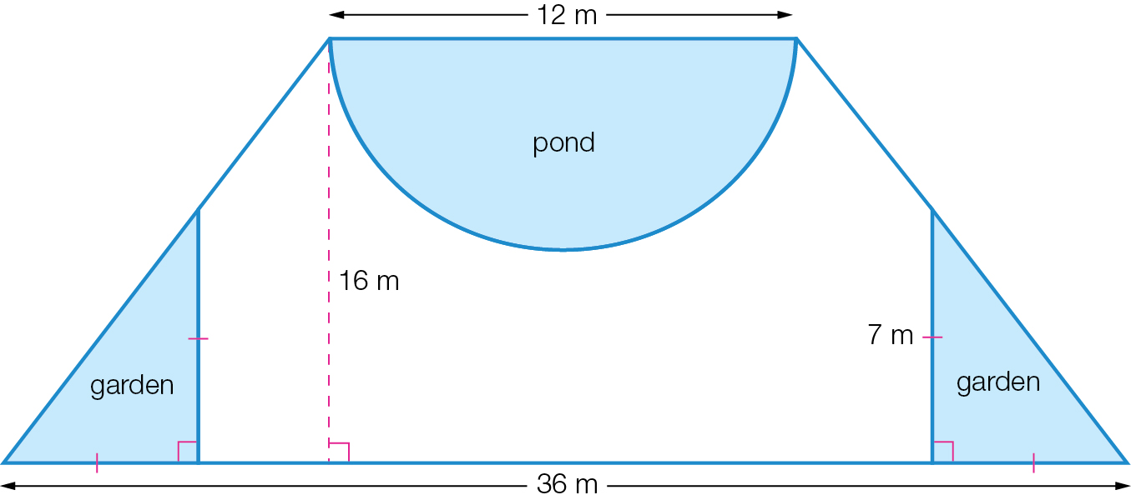

(a) (i) Find the area of Peter’s two garden beds.

(ii) If the soil needs to be 40 cm deep, how many cubic meters of soil does he need to purchase? Give your answer in cubic metres.

(b) The pond is 50 cm deep and in the shape of a semicylinder. If the side walls and the bottom of the pool need to be tiled, what is the total area of all the surfaces to be tiled? Give your answer to 2 decimal places.

(c) How many litres of water will be needed to fill the pond? Give your answer correct to the nearest litre.

(d) What area of the backyard will be covered with buffalo grass? Give your answer correct to 2 decimal places.

Extended answer results: \_\_\_ / 15

TOTAL test results: \_\_\_ / 55